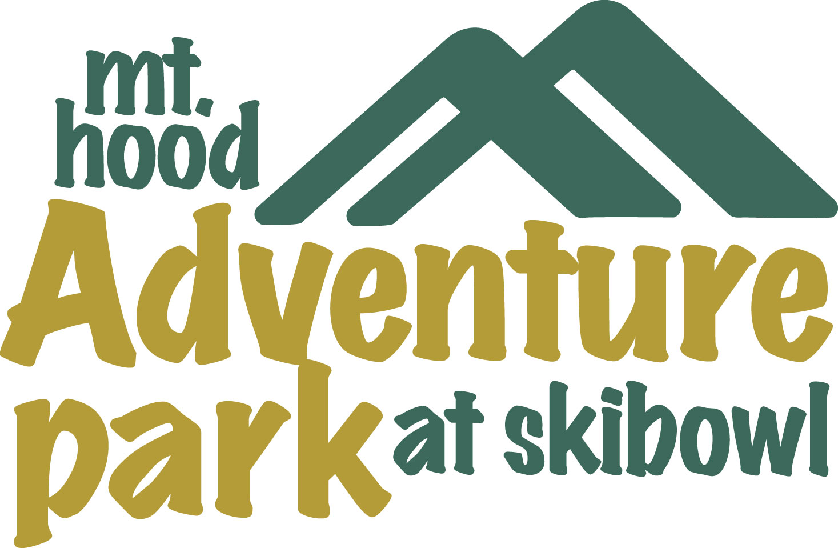
BEAR SPRINGS TRAP CROSS COUNTRY EVENT
MAY 1st, 2005

Race Info Line (503) 272-0146
Email: skibowlbikerace@aol.com
Website: www.skibowl.com
Hurricane Racing
P.O.Box 320, Government Camp OR 97028
Fax: (503) 272-0240

- Location: McCubbins Gulch located on Mt. Hood National Forest near Bear Springs Ranger station.
- Registration forms: can be downloaded from www.Skibowl.com or www.OBRA.org.
- Pre-registration: Entrance deadline is Thursday prior to event. Mail application to Hurricane Racing, P.O.Box 320, Government Camp, OR 97028 or fax application to 503-272-0240. Please, no e-mail registrations. As usual your registration fee will not be processed until we see your smiling face!
- Late Registration: at McCubbins Gulch finish area on Sunday 8:30am to 11:00am ($5.00 late registration fee).
- Entry fee: $15.00 for all participants
- Start Time: 10:45am for first category (for details please call our info line (503) 272-0146).
- Course: Single lap format for all classes in rolling terrain, starting with motorcycle trails, continuing on with very pristine single tracks. All types of surfaces and trail conditions for Pro/Expert (30+ miles). Sport uses shortened expert course (20miles). Beginner loop mostly on motorcycle trails (10miles). Free Shimano kids race. Look at directional signs instead of jumping over them or blowing by them – it will make your day better.
- Awards/Raffle: Following last racer arrival at finish area.
- Parking: You will be directed to various locations near the start/finish area.
- Directions: From Portland – 52 miles to Skibowl (maps will be provided and hung on Ski School’s door in the parking lot of Skibowl). Continue 19 miles on Hwy 26 east, turn left onto Hwy 216 to Maupin and follow posted signs to Registration/Start/Finish area. From Bend – Take Hwy 97 to Hwy 26 west through Madras/Warm Springs, then turn right onto Hwy 216 to Maupin, then follow posted signs.
- Camping: Free Campsites are available at Clear Creek Crossing Campground and Mc Cubbins Gulch Campground however you will need a NW Forest Pass.

